**STA 471 – Regression Analysis**

**Homework #2**

**September 21st, 2023**

Richard McCormick

RLM443



1. For the data given in **Problem F**, on **Page 99**…
   1. Test to determine whether there is a linear relationship between X and Y at α = 0.05. Be sure to state the null and alternative hypotheses, test statistic and its observed value, and conclusion.

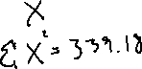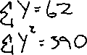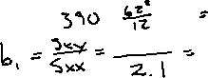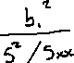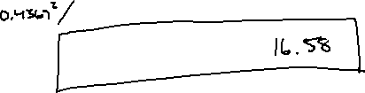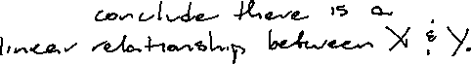

* 1. Calculate a 95% confidence interval for β1 and interpret the confidence interval. What is your conclusion based on the confidence interval?

